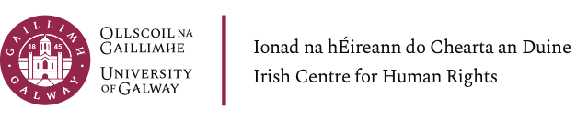

Summer School on the International Criminal Court
Online event

10 – 13 June 2024
Programme

Monday June 10th

09.30 Welcome
Professor Siobhan Mullally, Director, Irish Centre for Human Rights, University of Galway

Introduction to the International Criminal Court
Professor Shane Darcy, Irish Centre for Human Rights, University of Galway

11.00 Break

11.30 Jurisidiction & Admissiblity
Dr Rod Rastan, Legal Adviser, Office of the Prosecutor, International Criminal Court

13.00 Lunch break

14.00 The Crime of Aggression
Professor Sergey Vasiliev, Faculty of Law, Open University of the Netherlands

15.30 Close of lectures

Tuesday June 11th

09.30 Genocide
Professor William A. Schabas, Professor Emeritus, Irish Centre for Human Rights; Professor of International Law, Middlesex University

11.00 Break

11.30 Crimes against Humanity
Professor Chantal Meloni, University of Milan; Senior Legal Adviser, European Centre for Constitutional and Human Rights

13.00 Lunch break

14.00 War Crimes
Professor Ray Murphy, Irish Centre for Human Rights, University of Galway

15.30 Close of lectures

Wednesday June 12th

11.00 Victims before the International Criminal Court
Professor Luke Moffett, School of Law, Queens University Belfast

12:30 Lunch break

13.15 Panel discussion: Expectations and realities of justice at the International Criminal Court
- Vahe Grigoryan, Judge of the Constitutional Court of Armenia
- Maria Elena Vignoli, Senior Counsel, International Justice Program, Human Rights Watch
- Ahmed Abofoul, Senior Legal Research and Advocy Officer, Al-Haq
- Dr Owiso Owiso, international lawyer, scholar and consultant

15:00 Break

15.30 Evidence in international criminal trials
- Judge Beti Hohler, International Criminal Court; chaired by Dr Paul Bradfield, international criminal lawyer

17.00 Close of lectures

Thursday June 13th

09.30 Defending Cases at the International Criminal Court
Kate Gibson, Defence Counsel at the International Criminal Court / Mechanism for International Criminal Tribunals

11:00 Break

11:30 Penalties and Enforcement of Sentences at the International Criminal
Court
Dr Roisin Mulgrew, School of Law, University of Galway

13.00 Lunch break

14:00 The Future of International Criminal Justice
Judge Guénaël Mettraux, Judge, Kosovo Specialist Chambers, Adjunct Professor, Irish Centre for Human Rights

15:30 Close of Summer School

